King Fahd University of Petroleum and Minerals
College of Computer Science and Engineering
Information and Computer Science Department

ICS 201-02: Introduction to Computer Science
Fall 2007-2008
Quiz#4, Thursday November 29th 2007

Name:

ID#:

(20 points) Consider the following program:
import javax.swing.JFrame;
import javax.swing.JButton;
import java.awt.event.ActionListener;
import java.awt.event.ActionEvent;
import java.awt.BorderLayout;
import java.awt.Graphics;
import java.awt.Color;

public class ActionFace extends JFrame implements ActionListener
{
public static final int WINDOW_WIDTH = 400;
public static final int WINDOW_HEIGHT = 400;
public static final int FACE_DIAMETER = 200;
public static final int X_FACE = 100;
public static final int Y_FACE = 100;
public static final int EYE_WIDTH = 20;
public static final int EYE_HEIGHT = 10;
public static final int X_RIGHT_EYE = X_FACE + 55;
public static final int Y_RIGHT_EYE = Y_FACE + 60;
public static final int X_LEFT_EYE = X_FACE + 130;
public static final int Y_LEFT_EYE = Y_FACE + 60;
public static final int MOUTH_WIDTH = 100;
public static final int MOUTH_HEIGHT = 50;
public static final int X_MOUTH = X_FACE + 50;
public static final int Y_MOUTH = Y_FACE + 100;
public static final int MOUTH_START_ANGLE = 180;
public static final int MOUTH_ARC_SWEEP = 180;

private boolean wink;

public void actionPerformed(ActionEvent e)
{
wink = true;
repaint( );
}

public static void main(String[] args)
{
ActionFace drawing = new ActionFace( );
drawing.setVisible(true);
}

public ActionFace( )
{
setSize(WINDOW_WIDTH, WINDOW_HEIGHT);
setDefaultCloseOperation(JFrame.EXIT_ON_CLOSE);
setTitle("Hello There!");
setLayout(new BorderLayout( ));
getContentPane( ).setBackground(Color.white);

JButton winkButton = new JButton("Click for a Wink.");
winkButton.addActionListener(this);
add(winkButton, BorderLayout.SOUTH);
wink = false;
}

public void paint(Graphics g)
{
super.paint(g);
g.drawOval(X_FACE, Y_FACE, FACE_DIAMETER, FACE_DIAMETER);
//Draw Right Eye:
g.fillOval(X_RIGHT_EYE, Y_RIGHT_EYE, EYE_WIDTH, EYE_HEIGHT);
//Draw Left Eye:
if (wink)
g.drawLine(X_LEFT_EYE, Y_LEFT_EYE,
X_LEFT_EYE + EYE_WIDTH, Y_LEFT_EYE);
else
g.fillOval(X_LEFT_EYE, Y_LEFT_EYE, EYE_WIDTH, EYE_HEIGHT);
//Draw Mouth:
g.drawArc(X_MOUTH, Y_MOUTH, MOUTH_WIDTH, MOUTH_HEIGHT,
MOUTH_START_ANGLE, MOUTH_ARC_SWEEP);
}
}
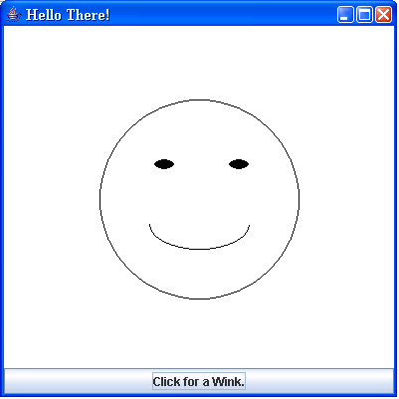

1. (4 points) What happens when one clicks the button "Click for a Wink"? Mention exactly what changes occur on the face and/or in the frame.
2.(16 points) Show all changes you would make to the above program so that the “Click for a Wink” button is replaced by a “Click for a Hat” button as follows:
  - (4 points) It appears at the top of the screen and not at the bottom, as shown below.
  - (12 points) Upon pressing the “Click for a Hat” button, A half circular hat with red color will be displayed.
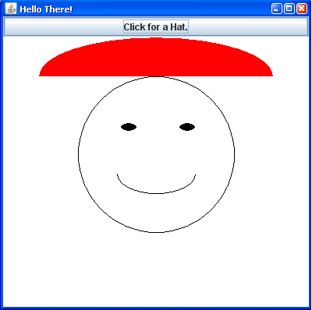
Indicate the lines you add (with their location in the program above) and/or delete. You do not have to rewrite the whole program.

King Fahd University of Petroleum and Minerals
College of Computer Science and Engineering
Information and Computer Science Department

ICS 201-02: Introduction to Computer Science
Fall 2007-2008
Quiz#4 Answer Sheet, Thursday November 29th 2007

Name:

ID#:

