ICS 201 | Quiz Number 7
ID: | Name:
Closed Book Quiz. You have exactly 20 minutes.
Closes the application
Fixed size
- Write a GUI-based application as shown below:
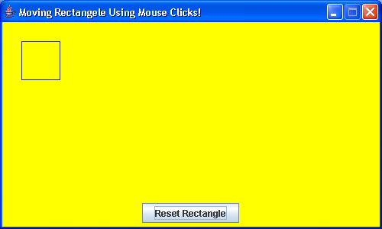

(25, 25)

Panel in the center

Yellow background
Panel in the south

When the user clicks on the mouse anywhere in the panel located in the center of the JFrame, the rectangle redraws itself with the new upper-left corner located at the mouse click position. If the user clicks on the “Reset Rectangle” button (which is added to a panel located in the south of the main frame), then the rectangle moves back to its initial position with its upper-left corner located at (25, 25).
Important Notes:
- The frame size is: 500 by 300 (width = 500 and height = 300).
- The rectangle size is: 50 by 50 (width = 50 and height = 50).
- The MouseListener or Adapter class should override the following method:
    - public void mouseClicked(MouseEvent me);
- To get the mouse coordinates, the class MouseEvent provides the following methods:
  - public int getX(): to get the X-coordinate of the location where the mouse has been clicked.
  - public int getY(): to get the Y-coordinate of the location where the mouse has been clicked.
- For the window events, you can either implement (extend) the WindowListener interface (or WindowAdapter class) and override:
      - public void windowClosing(WindowEvent we);
- The JFrame class provides a method for the purpose of handling the window closing operation:
      - public void setDefaultCloseOperation(int value);

- Write a Java program that displays the following Pie chart:



