**ICS 102 – Introduction to Computing**

**Spring Semester 152**

**Quiz # 6 Key**

**ID: Name:**

**Question # 1 [4 points]**

Show the output lines for each of the following program:

|  |  |
| --- | --- |
| Program | Output |
| public class Quiz6Q1  {  public static void main(String[] args)  {  int[][] mat = {{10,20}, {30,40,50}};  for (int r = 0; r < mat.length; r++)  {  for (int c = 0; c <= r; c++)  System.out.print(mat[r][c] + "\t");  System.out.println();  }  }  } | **10**  **30 40** |

**Question # 2 [6 points]**

Write Java statements to create the following array:

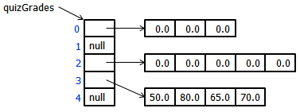

**double[][] quizGrades = {{0.0, 0.0, 0.0}, null, {0.0, 0.0, 0.0}, null, {50.0, 80.0, 65.0, 70.0}};**

**or**

**double[][] quizGrades = new double[5][];**

**quizGrades[0] = new double[3];**

**quizGrades[2] = new double[5];**

**double[] temp = {50.0, 80.0, 65.0, 70.0};**

**quizGrades[3] = temp;**