ICS 103-062
Quiz 2

Question 1: (4 points)
What is the output of the following c program
#include <stdio.h>
int main(void) {
int i,j;

for (i=2;i<=4;i++) {
j=4;
while(j>=i) {
switch(j-i) {
case 1: printf("X");
case 0: printf("Z"); break;
case 3: printf("M"); break;
default: printf("K");
}
j--;
}
printf("\n");
}
return 0;
}
Question 2 (6 points )
Write a program that will ask the user to enter how many days he has worked in the current month. Then, using a loop, it will ask him to enter number of hours worked in each day. Your program should display the total number of hours worked by the user in the current month.
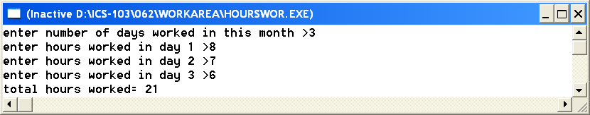

#include <stdio.h>
int main(void) {
int hours,n,i;
int sum=0;
printf("enter number of days worked in this month >");
scanf("%d",&n);
for (i=1;i<=n;i++) {
printf("enter hours worked in day %d >",i);
scanf("%d",&hours);
sum=sum+hours;
}
printf("total hours= %d",sum);
return 0;
}

