ICS 103-062
Quiz 2

Question 1: (4 points)
What is the output of the following c program?
#include <stdio.h>
int main(void) {
int i,j;
BABN
ABN
N
for (i=1;i<=3;i++) {
j=3;
while(j>=i) {
switch(j-i) {
case 1: printf("A");
case 2: printf("B"); break;
case 3: printf("C"); break;
default: printf("N");
}
j--;
}
printf("\n");
}
return 0;
}
Question 2 (6 points )
Write a program that will ask the user to enter how many books he has bought. Then, using a loop, it will ask him to enter the price of each book. Your program should display the total price of all books bought by the user.
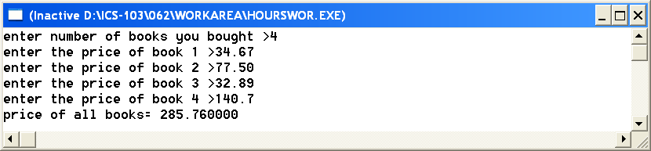

#include <stdio.h>
int main(void) {
int n,i;
double price,total=0;
printf("enter number of books you bought >");
scanf("%d",&n);
for (i=1;i<=n;i++) {
printf("enter the price of book %d >",i);
scanf("%lf",&price);
total=total+price;
}
printf("price of all books= %lf",total);
return 0;
}

