ICS 103-071
Quiz 3

Question 1: (4 points)
What is the output of the following program:

#include <stdio.h>
int main() {
12 13 7
11 6
5
4 5
int i,j;
i=7;
do {
j=5;
while(j<i){
printf("%d ",i+j);
j=j+1;
}
printf("%d\n",j);
i--;
} while(i>4);
printf("%d %d",i,j);
return 0;
}

Question 2: (6 points)
Write a program that reads from the user a number to guess how many values are in a file “data.txt”. Use do-while to make sure that the number entered is greater than 0. Then your program reads and counts the values in the file “data.txt”. Your program will display one of the 3 messages as shown below in the sample runs.
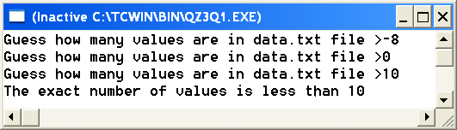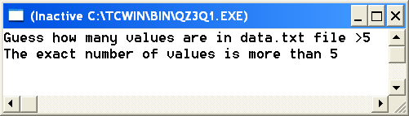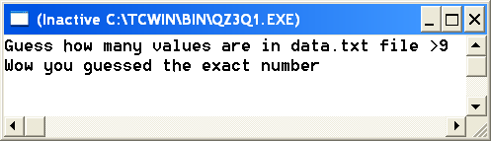
#include <stdio.h>
int main() {
int n,status,count=0;
double value;
FILE *in;
in=fopen("data.txt","r");

// check validity of input
do {
printf("Guess how many values are in data.txt file >");
scanf("%d",&n);
//if(n<=0)
// printf("The guessed number has to be greater than 0\n");
}while(n<=0);

// read from the file the values and count them
status=fscanf(in,"%lf",&value);
while(status!=EOF) {
count++;
status=fscanf(in,"%lf",&value);
}
fclose(in);

// dispaly the right message
if(n>count)
printf("The exact number of values is less than %d",n);
else if( n< count)
printf("The exact number of values is more than %d",n);
else
printf("Wow you guessed the exact number");
return 0;
}

