ICS 103-072
Quiz 1

Question 1: (3 points)
Complete the following program so that it runs and produces the output shown below

int main() {
________________ // declare age without decimal point
_________________ // declare income as real value
printf (“Enter your age and income >”);
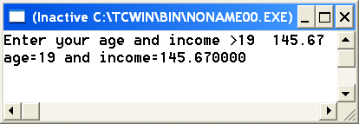

}

Question 2: (3 points)

Find the value of the expressions shown below
expression | Value

4%6

7/2*2

(double) (9/2)

5-7/6*6.0

5+3/2.0

2*6+5/2.0

Question 3 (2 points )
What will be the values of x, y, z, and after executing the following statements.
int x=6.84;
double y= (double)x;
double z=x/2;
int a= 7.0/4;
x y z a

Question 4: (2 points)
Show the output of the following program in the space provided below it. Each square corresponds to one space
#include <stdio.h>
int main(void) {
int t=538;
double x=72.136;
printf("%2d%5.2f\n",t,x);
printf("%10.4f%5d",x,t);
return 0;}

