ICS 103-072
Quiz 1

Question 1: (3 points)
Complete the following program so that it runs and produces the output shown below
#include <stdio.h>
int main() {
int age; // declare age without decimal point
double income; // declare income as real value
printf (“Enter your age and income >”);
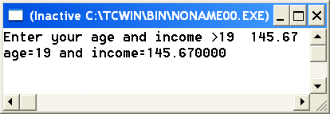
scanf(“%d%lf”,&age,&income);
printf(“age=%d income=%f”,age,income);
return 0;

}

Question 2: (3 points)

Find the value of the expressions shown below
expression | Value
4%6 | 4
7/2*2 | 6
(double) (9/2) | 4.0
5-7/6*6.0 | -1.0
5+3/2.0 | 6.5
2*6+5/2.0 | 14.5

Question 3 (2 points )
What will be the values of x, y, z, and after executing the following statements.
int x=6.84;
double y= (double)x;
double z=x/2;
int a= 7.0/4;
x y z a
6.0
6
3.0
1

Question 4: (2 points)
Show the output of the following program in the space provided below it. Each square corresponds to one space
#include <stdio.h>
int main(void) {
int t=538;
double x=72.136;
printf("%2d%5.2f\n",t,x);
printf("%10.4f%5d",x,t);
return 0;}
5 | 3 | 8 | 7 | 2 | . | 1 | 4
 |  |  | 7 | 2 | . | 1 | 3 | 6 | 0 |  |  | 5 | 3 | 8

