ICS 103-072
Quiz 2

Question 1: (3 points)

#include <stdio.h>
2 -1
4 1 -2
6

int main() {

int i,j;

i=2;

while(i<=4) {

for (j=i;j>=0;j=j-3)

printf("%d ",j);

printf("%d\n",j);

i=i+2;

}

printf("%d",i);

return 0;}

Question 2: (3 points)
Rewrite the following program fragment by converting the for loops into equivalent while loops.
for (i = 3; i < 50; i = i + 5) {
for (j = -i; j <= 1; j = j + i / 3)
sum = sum + i * j;
printf("sum =%lf\n",sum);}
i=3
while( i<50) {
j=-i;
while( j<= 1) {
sum=sum+i*j;
j=j+i/3;
}
printf(„sum=%lf\n”,sum);
i=i+5;
}

Question 3: (3 points)
Write a C program that asks the user how many books he read, then it will read pages in each book and prints total number of pages read by the user. A sample run is shown below.
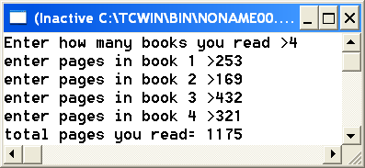
#include <stdio.h>
int main() {
int nbooks,i,npages;
int total=0;
printf("Enter How many books you read >");
scanf("%d",&nbooks);
for(i=1;i<=nbooks;i++) {
printf("Enter pages in book %d >",i);
scanf("%d",&npages);
total=total+npages;
}
printf("Total pages you read=%d",total);
return 0;}

