ICS 103-072
Quiz 3

Write a program containing the main function and another logical function checksides. Put the function definition of checksides after the main.

Your checksides function receives 3 integer numbers and checks if they form the sides of a triangle or not. Assume that the numbers are positive. Three numbers a,b, and c form the sides of a triangle if a+b>c, and a+c>b, and b+c>a.
Your main function reads integer numbers from a file. The numbers are positive and written 3 numbers per line. The file has 10 lines of numbers. Your program should use the functionchecksides to check if the numbers of each line form the sides of a triangle or not. It will print the numbers in another file, also 3 numbers per line and next to the numbers it will write “can be triangle sides” or “cannot be triangle sides”.
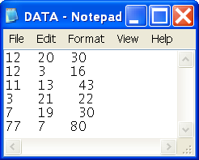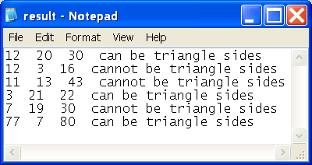

#include <stdio.h>
int checksides (int a, int b, int c);
int main() {
int a,b,c,i;
FILE *in,*out;
in=fopen("data.txt","r");
out=fopen("result.txt","w");
for(i=1;i<=10;i++) {
fscanf(in,"%d%d%d",&a,&b,&c);
if(checksides(a,b,c))
fprintf(out,"%d %d %d can be triangle sides\n",a,b,c);
else
fprintf(out,"%d %d %d cannot be triangle sides\n",a,b,c);
}
fclose(in);
fclose(out);
return 0;
}
int checksides (int a, int b,int c) {
if(a+b>c && a+c> b && b+c >a)
return 1;
else
return 0;
}

