ICS 202-52 LAB QUIZ#01 (Term 202)

Instructions: Submit in ICS 202_52 Blackboard the .java files for:
- The modified SLL<T> class
- The given SLLNode<T> class
- The driver program.

Zip the required java files in a .zip or .rar file named in the format:
LabSection#_LabQuiz01_KFUPMID#_FamilyName
Example:
52_LabQuiz01_200000000_AlGhamdi

Note: Your quiz will not be graded if any of the submission guidelines is not followed.

- Assume that the nodes of an SLL<T> object are numbered starting from 1.

Example:
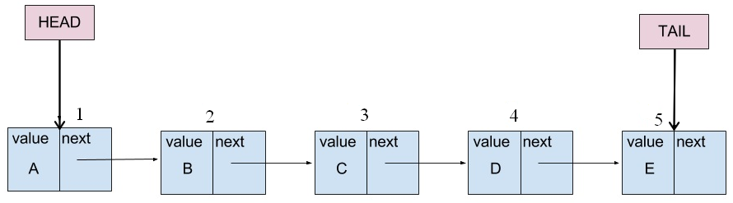

Modify the given SLL.java file by writing an instance method: public void insertList(int n, SLL<T> list2) of SLL<T> class that inserts list2 before node n in the invoking SLL<T> object. If n == 1 + length of invoking object or if the invoking list object is empty, list2 must be inserted at the end of the invoking list object. Your method may use other SLL<T> methods.

Examples:
Invoking list | list2 | n | Resulting list
5, 7, 4, 8, 6, 2 | 10, 20, 30 | 3 | 5, 7, 10, 20, 30, 4, 8, 6, 2
3, 1, 0, 9 | 25, 70, 12, 40 | 1 | 25, 70, 12, 40, 3, 1, 0, 9
8, 6, 2 | 50, 40, 80 | 4 | 8, 6, 2, 50, 40, 80

Note:
- Your method must throw java.util.IllegalArgumentException if n <= 0 or if the invoking list object is empty.
- Your method must throw java.util.IllegalArgumentException if list2 is empty.
- Your method must throw java.util.IllegalArgumentException if n > 1 + length of the invoking list object.
- You are only allowed to use the given SLL<T> and SLLNode<T>

- Write a driver class to test the method public void insertList(int n, SLL<T> list2). Your driver must test:
- All invalid cases.
- Inserting list2 at the beginning.
- Inserting list2 at the end.
- Inserting list2 at a position that is neither the beginning nor the end.

