**Question 1:** For each of the following activities, give a PEAS description of the task environment and characterize it in terms of the properties (observability, single or multi-agent, deterministic/ stochastic, episodic/sequential, static/dynamic/semi, discrete/continuous).

1. Part-picking robot
2. Interactive tutor
3. Search engine
4. Playing soccer
5. Tic-tac-toe game

|  |  |  |  |  |
| --- | --- | --- | --- | --- |
| Agent type | Performance measure | environment | Actuators | Sensors |
| 1 | Percentage of parts in correct bins | Conveyor belt with parts, bins | Jointed arm, hand | Camera, joint angle sensors |
| 2 | Maximize student's score on test | Set of students | Screen display | Keyboard entry, mouse/ touch screen |
| 3 | locating the most accurate search results, Fast | Computer, server, internet connection | Screen display, search functions | Keyboard entry, mouse/ touch screen, camera |
| 4 | Play, Make a goal, Win, Defend | Soccer, Team Members, Opponents, Referee, Audience, Soccer Field | Legs, hands, mouth | Eyes, ears, skin feeling |
| 5 | Win | Paper | Pencil, hands | Eyes |

|  |  |  |  |  |  |  |
| --- | --- | --- | --- | --- | --- | --- |
| Agent type | observability | Single/multi-agent | deterministic/ stochastic | episodic/sequential | static/dynamic/semi | discrete/continuous |
| 1 | Partially Observable | Single Agent | Stochastic | episodic | Dynamic | Continuous |
| 2 | Partially Observable | Multi Agent | Stochastic | Sequential | Dynamic | Discrete |
| 3 | Partially Observable | Single Agent | deterministic | Sequential | Semi-dynamic | Discrete |
| 4 | Partially Observable | Multi Agent | Stochastic | Sequential | Dynamic | Continuous |
| 5 | Fully Observable | Multi Agent | Deterministic | Sequential | Static | Discrete |

**Question 2:** Draw the complete state space representation for the farmer, goat, wolf, cabbage problem which is descripted as follows. A farmer with his goat, wolf and cabbage are one side of a river (Say West Bank). The farmer wants to move with the other characters to the other side of the river (Say East Bank). There is a boat that can carry only two things at most. Only the farmer can row the boat. The wolf should not be left alone with the goat and the goat should not be left alone with the cabbage. Let nodes in the state space represent the location of each element, e.g. (w,e,w,w) means farmer, wolf and cabbage are on west side and goat on east side. Indicate the initial and goal states and show a sequence of valid transitions to reach to the goal.

Single direction Association

(Return is not possible)

bidirectional Association

(Return is possible)

Valid state

Invalid state

Goal state

**Question 3:** Apply each of the following graph search strategies on the given graph. Show clear steps and the order in which states are expanded as well as the path returned by each strategy and its cost to the goal. Assume ties to be resolved in alphabetical order and a state is expanded only once. Also assume the agent starts at **S** and wants to reach any of the goal states {G1, G2, G3}.

1. Depth-first search (DFS)
2. Breadth-first-search (BFS)
3. A picture containing items

   Description automatically generatedIterative deepening search (IDS)
4. Uniform cost search (UCS)
5. 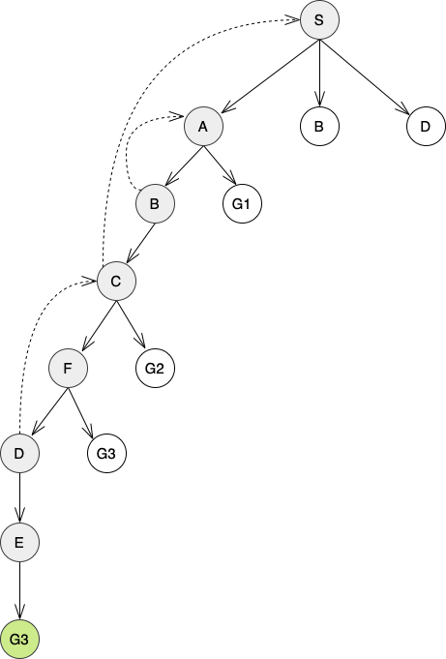DFS

Steps: S 🡪 A 🡪 B 🡪 C 🡪 F 🡪 D 🡪 E 🡪 G3

Path: S 🡪 A 🡪 B 🡪 C 🡪 F 🡪 D 🡪 E 🡪 G3

Cost: 27

1. BFS

Steps: S 🡪 A 🡪 B 🡪 D 🡪 G1

Path: S 🡪 A 🡪 G1

Cost: 14

1. IDS

* d = 0
  + Steps: S
  + Cost: 0
* d = 1
  + A screenshot of a computer

    Description automatically generated with low confidenceSteps: S 🡪 A 🡪 B 🡪 D
  + Cost: 5 + 9 + 6 = 20
* d = 2
  + Steps: S 🡪 A 🡪 B 🡪 G1
  + Cost: 17

Path: S 🡪 A 🡪 G1

Search cost: 0 + 20 + 17 = 37

Path cost: 14

1. UCS

Steps: S(0) 🡪 A(5) 🡪 D(6) 🡪 B(8) 🡪 C(8) 🡪 E(8) 🡪 G2(13)

Path: S(0) 🡪 D(6) 🡪 C(8) 🡪 G2(13)

Path cost: 13

Resources used:

ICS 381 official book.

Draw.io (Diagrams editing).