**Department of Information and Computer Science**

**ICS 381: Principles of Artificial Intelligence  
Second Semester 2018/2019 (182)**

**Quiz No. 2**

**Name: ID:**

**Question 1:**

Two cars, **Car_A** and **Car_B**, use the simple highway network shown below.

**Car_A**

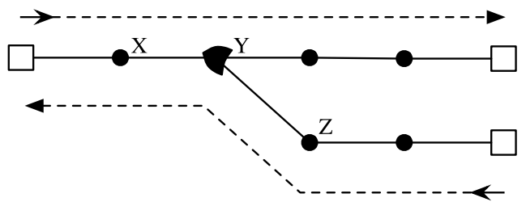

**Car_B**

The traffic department decides to schedule a single daily departure for each car. Each departure will be on **an hour**, **between 1 pm and 7 pm, inclusive**. The cars **run at identical, constant speeds, and each segment takes** a car one hour to cover.

You are required to model this problem as a constraint satisfaction problem (CSP) in which the variables represent the departure times of the cars from their source stations.

Assume that the variables **A** and **B** are used to model both variables (**Car_A** and **Car_B**).

1. What are the domains of both variables to represent the departure times?

**A ∈ {1, 2, 3, 4, 5, 6, 7}**

**B ∈ {1, 2, 3, 4, 5, 6, 7}**

The complication is that the cars cannot pass each other in the region of the highway that they share, and will collide if improperly scheduled. The only points in the shared region where the two cars can pass or touch without a collision are the points indicated in **squares** and the intersection **Y**.

**Example 1:** The **A-Car** and **B-Car** both depart at 4 pm. At 6 pm, the **A-Car** will have reached the intersection **Y**, clearing the shared section of the highway. The **B-Car** will have only reached point **Z**. No collision will occur.

**Example 2:** The **A-Car** leaves at 4 pm and the **B-Car** at 2 pm. At 5 pm, the **A-Car** will be at point **X** and the **B-Car** at the intersection **Y**. They will then collide around 5:30 pm.

1. If the **B-Car** leaves at 1 pm, list the times that the **A-Car** can safely leave without causing a collision?

**A ∈ {1, 2, 6, 7}**

**B ∈ {1 }**

1. Implicitly state the binary constraint between the variables for **A-Car** and **B-Car** for this CSP. Your statement should be precise, involving variables and inequalities, not a vague assertion that the two cars should not collide.

**A < B + 2 OR A > B + 4**

1. Imagine the **A-Car** must leave between 4 pm and 5 pm, inclusive, and the **B-Car** must leave between 1 pm and 7 pm, inclusive. State the variables’ domains after these unary constraints have been imposed.

**A ∈ {4, 5}**

**B ∈ {1, 2, 3, 4, 5, 6, 7}**

1. Put an **X** through any domain value above that is removed by applying arc consistency to these domains.

**A ∈ {4, 5}**

**X**

**X**

**B ∈ {1, 2, 3, 4, 5, 6, 7}**