**Department of Information and Computer Science**

**ICS 381: Principles of Artificial Intelligence  
Second Semester 2018/2019 (182)**

**Quiz No. 5**

**Name: ID:**

**Name: ID:**

**Name: ID:**

**Name: ID:**

**Question 1:**

You are called to assist a physician to diagnose patients with a specific symptom (**S**). You are informed that:

1. Two different diseases, **A** and **B**, may cause this symptom.
2. The variation of a gene **G** plays a big role in the presence of disease **A**.

To carry out your diagnosis, you intend to model the problem as a Bayesian network. This network is shown below:

**P(B)**

|  |  |
| --- | --- |
| P(B = +b) | 0.6 |
| P(B = **-**b) | 0.4 |

|  |  |
| --- | --- |
| P(G = +g) | 0.9 |
| P(G = **-**g) | 0.1 |

**P(G)**

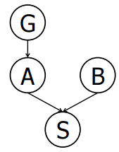

**P(S | A, B)**

|  |  |  |  |
| --- | --- | --- | --- |
| +a | +b | +s | 1.0 |
| +a | +b | -s | 0.0 |
| +a | -b | +s | 0.9 |
| +a | -b | -s | 0.1 |
| -a | +b | +s | 0.8 |
| -a | +b | -s | 0.2 |
| -a | -b | +s | 0.1 |
| -a | -b | -s | 0.9 |

**P(A | G)**

|  |  |  |
| --- | --- | --- |
| +g | +a | 1.0 |
| +g | -a | 0 |
| -g | +a | 0.1 |
| -g | -a | 0.9 |

1. Compute the following entry from the joint distribution:

**P(+g, +a, +b, +s) = P(+g) P(+a | + g) P(+b) P(+s | + b, +a) = (0.9)(1.0)(0.4)(1.0) = 0.54**

1. What is the probability that a patient has disease **A**?

**P(+a) = P(+a | + g) P(+g) + P(+a | -g) P(-g) = (1.0) (0.9) + (0.1) (0.1) = 0.91**

**Question 2:**

Consider the following Bayesian network structure:

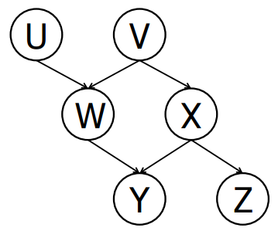

Circle whether the following conditional independence assertions are guaranteed to be true, guaranteed to be false, or cannot be determined by the structure alone.

|  |  |  |  |
| --- | --- | --- | --- |
| **Case** | **Option 1** | **Option 2** | **Option 3** |
|  | **Guaranteed true** | **Cannot be determined** | **Guaranteed false** |
|  | **Guaranteed true** | **Cannot be determined** | **Guaranteed false** |
|  | **Guaranteed true** | **Cannot be determined** | **Guaranteed false** |
|  | **Guaranteed true** | **Cannot be determined** | **Guaranteed false** |
|  | **Guaranteed true** | **Cannot be determined** | **Guaranteed false** |
|  | **Guaranteed true** | **Cannot be determined** | **Guaranteed false** |
|  | **Guaranteed true** | **Cannot be determined** | **Guaranteed false** |
|  | **Guaranteed true** | **Cannot be determined** | **Guaranteed false** |